M E M O R A N D U M

TO: Lonnie Shull III, Permit Writer

FROM: Chris Bittner, Standards Coordinator

DATE: April 3, 2021

SUBJECT: Level I Antidegradation Review for Compass Minerals Permit Renewal
UT0000647

Outfall 001. No substantive changes are observed for the effluents from Outfall 001 that would affect the conclusions that the effluent limits from the previous permit will protect the uses of Great Salt Lake (R317-2-6.5).

Outfalls 006, 007, and 008

Compass operates several outfalls for mineral return flows. The primary purpose of mineral return flows is to return the leftover salts in the evaporation ponds back to the Great Salt Lake. Water from Bear River Bay is conveyed to the various evaporation ponds and then back to Bear River Bay. The immediate receiving waters for the return flows are bound by railroad bridges to the north and south and are informally known as the Trapezoid (Figure 1). The Trapezoid is designated as Bear River Bay (R317-2-6.5.c.). However, the water quality characteristics of the Trapezoid are much more similar to Gilbert Bays south of the Union Pacific bridge than Bear River Bay upstream of the bridge that forms the northern boundary of the Trapezoid. This bridge is located at a land constriction where the dominant flow direction is from north to south and fresher to more saline. As indicated by the elevated salinity in the Trapezoid relative to upstream, more saline Gilbert Bay waters regularly influence the Trapezoid.

Compass Minerals does not add any substances to the evaporation ponds. All the substances in the return flows originated from the Lake. The primary purpose of the monitoring conducting during the mineral return flows is to confirm that the Narrative Standards (R317-2-7.2) are met. The results of the monitoring were reviewed to ensure that existing uses are protected (Level I antidegradation review; R317-2-3).

Figure 1 shows the monitoring locations for the mineral return flows. In addition to the return flow monitoring at Outfalls 006, 007 and 008, the receiving waters directly affected by return flows (Mid Trapezoid) and locations that represent ambient conditions for the Lake (Background North, GSL-NE and South Promontory Point) were also monitored.

Prior to 2017, the analyses for the mineral return samples were provided by the Geosciences laboratory at the University of Utah. Beginning in 2017, Brooks Applied Laboratories provided the analyses. In 2018, the samples were split between the University of Utah and Brooks Applied laboratories. The splits were analyzed to verify that the Brooks Applied Laboratory data were comparable to the University of Utah. Comparability is one of the EPA-recommended data quality objectives in addition to precision, accuracy, and completeness.

The tables presented on pages 10 through 13 provide the analytical results for 2017 return flow monitoring. The results for 2018, 2019, and 2020 are provided in the tables beginning on page 14. The results from the two laboratories for arsenic, lead, manganese and mercury are generally comparable whereas the results for cadmium, copper, nickel, selenium and zinc are generally different. The causes of the differences are unknown. Figures 2 and 3 illustrate these observations for results from the two laboratories for the GSL NE and Outfall 006 sample locations, respectively.

The general trends observed in concentrations over time are similar regardless of analyte. As expected, concentrations for the mineral return flows from Outfall 006 generally decrease over time (Figure 3). Based on the currently available information, the Brooks Applied Laboratory data are presumed to be the most representative because of completeness, more rigorous quality control documentation, and because DWQ has previously observed positive interferences with Great Salt Lake selenium analyses from the University of Utah laboratory.

Figure 4 compares the concentrations observed at Outfall 006, Mid Trapezoid and GSL NE sample locations from the fall, 2018. These results are similar to the other years of mineral return flows. The fall 2018 results show that arsenic, mercury, nickel, selenium and zinc are initially present in the mineral return flows at concentrations 3 to 7 times greater than ambient waters in Gilbert Bay but by Day 27 the concentrations decreased to close to ambient concentrations. If the maximum concentrations are screened against Utah Class 3D freshwater criteria (Table 2.14.2, R317-2-14), only the arsenic and mercury screening criteria are exceeded. The rapid assimilation demonstrated by comparing the analytical results from the Outfall 006 to the Mid Trapezoid and GSL NE sample locations and the limited bird use documented by the Jacobs Engineering 2017-2018 bird survey supports that the mineral return flows are unlikely to adversely impact the designated uses of the receiving waters. These results also support that seasonal restrictions for the mineral return flows are unnecessary.

Monitoring is recommended to continue until return flows for all different return flow conditions and ponds have been characterized. The currently available results support that monitoring beyond about Day 28 of the return flows is unnecessary because concentrations approach ambient concentrations. At minimum, arsenic, mercury, nickel, selenium and zinc should be retained as target analytes. The summary monitoring and reporting should also include a measure of salinity such as conductivity.
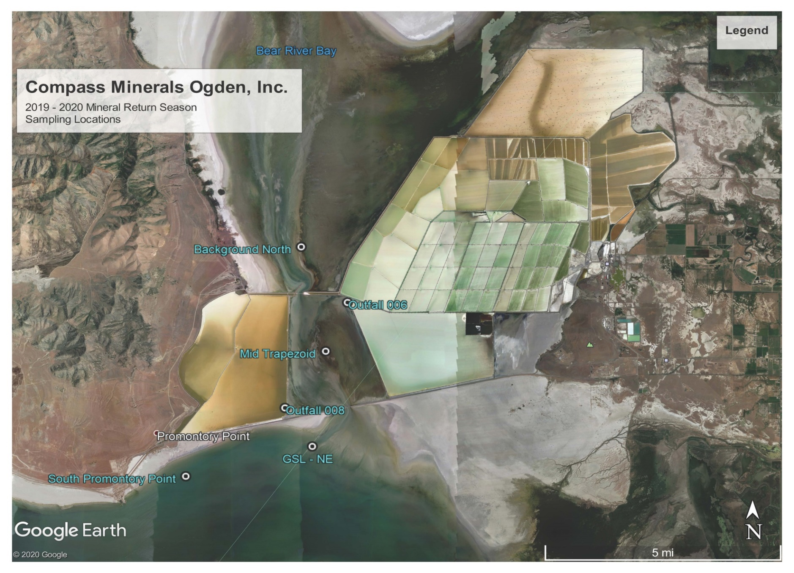
Figure 1. Sampling locations for mineral return flow monitoring, Compass Minerals, Great Salt Lake, Utah

Figure 2. Comparisons of analytical results from Brooks Applied Laboratories (BR) and University of Utah Geosciences (UU) laboratories from GSL-NE sample location, November 2018

Figure 3. Comparisons of analytical results from Brooks Applied Laboratories (BR) and University of Utah Geosciences (UU) laboratories from Outfall 006, November 2018

Figure 4. Comparisons of analytical results from South Promontory, Mid-Trapezoid, and Outfall 006 monitoring locations from the Brooks Applied laboratory for November 2018

